Day 9:
Spring:
1-3) Coding Parts uploaded in Github.

4)Applicationcontext.xml file:
applicationContext.xml is the main configuration file in a traditional Spring application (XML-based configuration). It tells the Spring IoC (Inversion of Control) container:
Which Java classes (beans) to create.
How to create them.
How to inject dependencies between them.
Any additional configuration required.
<beans> It is the root element of the configuration.
<bean id="student" class="com.spring.Student"/> - id is the unique name of the bean used to retrieve the bean from the spring container.
Class is the classname , Where spring will creates the object for the class.
<bean id="student" class="com.spring.Student">

<property name="name" value="Bharath"/>
<property name="age" value="22"/>

</bean>
Property injection: where spring automatically set student.setName(“Bharath”);
Constructor-arg:Helps to inject the object of the class in the constructor.
Ref: Refers to the other beans.

5) Application Context uses:
To Configure the beans and how to use them
How to inject dependencies.
How to define the scope of the Beans and their lifetimes within the application
6)Features of Spring:
Inversion of Control – Spring itself manages the lifecycle and creation of beans.
Dependency Injection – It Automatically inject the objects when its needed.
Aspect Oriented Programming – Cross Cutting Concerns.

7) The Spring Framework is used to develop robust, scalable, secure, and maintainable Java enterprise applications
Advantages:
Inversion of control
Aspect Oriented Programming
Dependency Injection
Transaction Management
Easy connection with Databases
High Security Support.

8) Inversion of Control (IoC) is a core principle of the Spring Framework in which the control of creating and managing objects (beans) is transferred from the programmer to the Spring IoC Container.
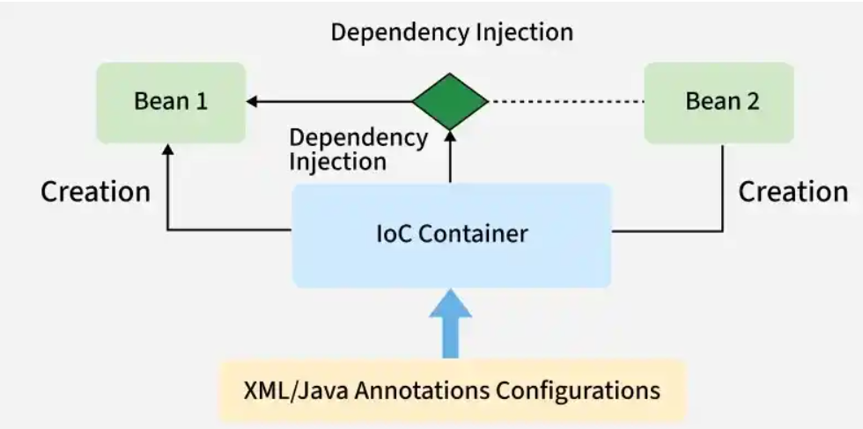

9)Types of IOC:
- The BeanFactory is the simplest and most lightweight container in Spring. It provides basic features for bean creation and management but lacks advanced functionalities such as event handling and AOP.
- The ApplicationContext is a more advanced and feature-rich container compared to BeanFactory. It extends BeanFactory and adds additional features such as event propagation, AOP support, and internationalization.

10) Spring Dependency Injection:
Dependency Injection (DI) is a design pattern used by the Spring Framework to implement Inversion of Control (IoC). It is the process of providing the required dependencies (objects) to a class from the Spring IoC container instead of the class creating them itself.

11) Types of DI:
When we inject the dependency of one class into another class via the constructor, then it is called constructor injection.
When we inject the dependency of one class into another class via the setter method, then it is called setter injection.
Dependencies are injected directly into the field by using the @Autowired or manually.
This is nothing but field injection.

12) Spring Application Configuration is the process of defining and managing Spring beans, their dependencies, and application settings so that the Spring IoC container can create and manage them.

13) Ways of Spring application configuration

- XML Configuration (applicationContext.xml)
- Annotation-based Configuration (@Component, @Service, @Repository, etc.)
- Java-based Configuration (@Configuration and @Bean)

14)why we need spring app configuration:
- To define Spring beans.
- To manage dependencies.
- To configure bean scopes and lifecycle.
- To enable loose coupling.
- To let the Spring IoC container manage objects.

15)Bean Scopes:
Bean Scope defines how many instances of a bean Spring creates.

- Singleton (Default) – One instance per Spring container.
- Prototype – New instance every time the bean is requested.
- Request – One instance per HTTP request.
- Session – One instance per HTTP session.
- Application – One instance per web application.
- WebSocket – One instance per WebSocket session.

16) Autowiring is a feature in Spring that automatically injects the required dependency into a bean without explicitly configuring it.

17) Annotation-based Autowiring
- @Autowired
- @Qualifier
- @Primary

18) Normal Java Object Spring Bean
Created using new Created by Spring IoC Container
Lifecycle managed by programmer Lifecycle managed by Spring
Dependencies created manually Dependencies injected automatically
Tight coupling Loose coupling

19)
@Component | @Bean

Used on a class | Used on a method

Automatically detected by component scanning | Declares a bean explicitly

Used for application classes

Requires @ComponentScan | Requires @Configuration

23) Spring Annotation:
@Bean – Creates a Spring bean manually inside a configuration class.
@Controller – Marks a class as a web controller that handles HTTP requests.
@Value – Injects values from properties files or environment variables.
@ComponentScan – Tells Spring where to find components and beans.
@Configuration – Defines a class that contains Spring configuration and bean definitions.
@Service – Marks a class as a service layer containing business logic.
@Repository – Marks a class as a database access layer component.
@Qualifier – Specifies which bean to inject when multiple beans of the same type exist.
@Required – Marks a property as mandatory for bean configuration (deprecated).
@Component – Marks a class as a Spring-managed component.
@Autowired – Automatically injects dependencies into a class.
@Scope – Defines the lifecycle of a Spring bean.

24)Features of Spring boot:
- Auto Configuration.
- Starter Dependencies
- Embedded Server

25)Advantages of Spring boot:
- Faster Development
- No XML Configuration
- Embedded Server
- Auto Configuration
- Production Ready
- Easy Testing
26)Key Components of Spring boot:
- Spring boot Starter
- Auto Configuration
- Spring boot Actuator
- SpringApplication Class

27)
Spring Framework | Spring Boot
More configuration | Minimal configuration
XML configuration | Annotation-based
External Tomcat required | Embedded Tomcat
Manual dependency management | Starter dependencies
Longer setup | Quick setup
Deployment as WAR | Executable JAR
Slower development | Faster development

28) Spring boot internal working
In simple flow:
main() → SpringApplication.run() → ApplicationContext creation → Component Scanning → Auto Configuration → Bean Creation → Embedded Server Start → Application Ready

29) Some commonly used starter dependencies are:
Starter Dependency | Purpose
spring-boot-starter | Core starter
spring-boot-starter-web | Spring MVC and REST APIs
spring-boot-starter-data-jpa | JPA and Hibernate
spring-boot-starter-jdbc | JDBC support
spring-boot-starter-security | Spring Security

30) main()
↓
SpringApplication.run()
↓
Create SpringApplication
↓
Create ApplicationContext
↓
Process @SpringBootApplication
↓
Component Scan
↓
Auto Configuration
↓
Load application.properties
↓
Start Embedded Tomcat
↓
Application Ready

31) syntax to change the Tomcat Server port number
mvn spring-boot:run -Dspring-boot.run.arguments="--server.port=8081"

